 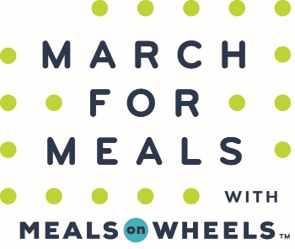 

**5K Run/Walk & 1 Mile Run/Walk**

**Saturday, March 25, 2017**

**All Proceeds Support Bond County Meals on Wheels Program**

**5K starts at 9:00 am 1 Mile starts at 9:45 am**

Location: Starts and Ends at Bond County Senior Center, 1001 E. Harris Ave., Greenville, IL 62246

Awards: Awards will be given to the top male and female finishers overall and in the following age groups: 14 & under, 15-24, 25-34, 35-44, 45-54, 55 & over. Award finishers must be present to receive their award.

Registration: $ 25 if postmarked by 3/17/17. $30 if postmarked after 3/18/17 or later and Race Day entry fee. NOTE: ENTRY FEES ARE NON-REFUNDABLE

Shirts: Event T-shirts available for pre-registered entrants. Race day and late registration are not guaranteed a shirt.

Information: Registration forms can be downloaded from [www.bondseniors.org](http://www.bondseniors.org/), picked up at Bond County Senior Center or on Bond County Senior Center Facebook page. For more information please contact Jill Jones at 618-664-1465 or email [jill.jones@bondcountytransit.org](mailto:jill.jones@bondcountytransit.org) or Chrisy Ennen at [clennen@hotmail.com](mailto:clennen@hotmail.com).

**___ ___ ___ ___ ___ ___ ___ ___ ___ ___ ___ ___ ___ ___**

**MARCH FOR MEALS – 5K RUN/WALK & 1 MILE RUN/WALK**

Make Checks Payable to: Bond County Senior Center, 1001 E. Harris Ave., Greenville, IL 62246

***FRIEND DONATION: $20 $30 $40 $50 $75 $100 Other _____***

*Will be recognized as a donor on the day of the event*

**Name: ____________________________ Phone: ______________________**

**Address: __________________________ Age (on race day): _____________**

**City/State/Zip: _____________________ Circle Gender: Male Female**

**Circle T-shirt Size: Youth-M Youth-L Adult-S Adult-M Adult-L Adult-XL Adult-XXL**

**Circle Event: 5k Run 5k Walk 1Mile Run 1Mile Walk Silent Walker**

*(A silent walker is an entrant that will not make the event but will receive event T-shirt)*

Waiver of Liability: In consideration of this entry, I the undersigned, intending to be legally bound, hereby, for myself, my heirs, executors and administrators, waive and release any and all rights and claims for damages, actions and causes of actions against Bond County Senior Citizens Center, Inc., BondCoRunCo, Meals on Wheels America and their affiliates, subsidiaries, officials, representatives, employees, successors and assigns for any and all injuries suffered by me in said event. I attest and verify that I am physically fit and have sufficiently trained for the completion of the run/walk. Further, I hereby grant full permission for the free use of my name and/or photographs, videotapes, motion pictures, recordings, and any other record of this event for any legitimate purpose.

**Signature: _______________________________________________ Date: _______________**

**Email address: __________________________________** (used for entry confirmations – not given out to other entities)